Analysis of Context Aware and Adaptive Multi-Factor Authentication Models

Baker Womack
Dep. Of Computer Science and Eng.
University of South Carolina

Abstract
While traditional multifactor authentication (MFA) methods are secure, they often fail to continuously authenticate or cause friction for users, leading to insecure behaviors such as simple passwords or MFA fatigue. As a result, there is a growing interest in finding new passive authentication methods that allow for simple usage and the ability to continuously authenticate the user.
This work evaluates several passive authentication frameworks such as CASA, CSAW, and MMauth, which enables us to identify the benefits, along with the different limitations that can be improved upon. By generating realistic users using virtual android devices, we have been able to use a support vector machine (SVM) to analyze the data. An SVM is a type of machine learning algorithm that separates data into categories by drawing the best possible line or boundary between them. This allowed us to achieve 98% accuracy along with a 3% error rate.
The results have shown that by using a combination of features about the user and the mobile device, it significantly improves the reliability and consistency of passive authentication.
I. Introduction
Despite widespread adoption, MFA is increasingly resisted due to poor usability. Users are often unwilling to engage in the increasingly complex authentication steps, which have led to insecure behavior. The traditional “something you know” and “something you have” are reaching a practical limit. Users are now leaving computers or accounts open for the sake of not having to authenticate. Security systems often cannot verify whether the current user is the legitimate one through a session. The simple approach would be to have the user continuously authenticate, but as we have seen, the very fact of authenticating burdens the user enough.
Smartphones and the typical behavior of users can be a rich source of data, which enables us to model these habits and to be able to detect abnormalities. Previous works have presented different frameworks of passive authentication, however, most have limits in practicality.
This paper analyzes the previous work done and evaluates the best balance between security and usability. Overall, enhancing protection without increasing friction.
II. Background
Since the creation of computer security, passwords and pins have been the method of securing accounts or devices. As attackers have advanced, there has been an introduction of MFA, but still has not been completely adopted by users as there is now an extra step to logging into their account. Thus, recent data has shown that 94% of leaked passwords are reused or weak with only 6% being truly unique. [7] Meaning that the use of passwords needs to be reduced, and a transition to a different approach is necessary. In fact, stolen credentials were involved in 38% of confirmed data breaches. [8] Additionally, most of these credentials were taken through phishing attempts, where either MFA was not used or a simple MFA bypass was used.
Even with the use of new MFA methods, since they are not continuous, attackers will continue to only have to bypass authentication once. The current use of account security has relied too long on static credentials and are unable to adapt to the user in their environment or can evaluate real time risk.
III. Related Work and Current Approaches
There are two forms of authentication being used, passive and active authentication. Active authentication focuses on where the user is having to actively do something, such as enter a code, click accept, or listen to a phone call. This has been the overwhelmingly dominant form in the industry but tends to fail with any form of continuous authentication. As such there has been a large push for finding a solution to use passive and continuous authentication at an enterprise level.
One approach used a CNN [2] in combination with an Isolation Forest (iForest) to be able to enhance the authentication. An iForest is an unsupervised machine learning algorithm that is used to detect anomalies by isolating outliers instead of profiling with normal data. This works especially well in larger datasets but is resource intensive. Using this method, they have obtained 93% accuracy without the use of user integration. Since these datasets were based only on motion sensor data, it seems to lack real-world application. It was also found to be very resource consumptive.
Another approach [6] used a CNN but combined this model with a Long Short-term Memory (LSTM) model for authentication. An LSTM is a type of recurrent neural network (RNN) that is specifically designed to learn and remember patterns over time, making it more useful for analyzing sequential data like motion or time-series signals. They were able to achieve 97% accuracy, which outperforms these models when used independently. However, similar issues arise, as with the iForest, as it was found to be very resource intensive and relied on stable motion behavior. As such, real-world application was limited.
The Context-Aware Scalable Authentication (CASA) framework [3], shifts to a different approach by instead using different contextual factors like location and Wi-Fi proximity. By using a Naive Bayes classifier, authentication levels were able to be adjusted dynamically. This classifier is based on Bayes’ Theorem which assumes all features are independent from one another. It's known to be lightweight and works well with limited data. This focus was not on improving the model's accuracy of authentication but rather focusing on reducing user burden and was able to reduce the number of active authentications needed by 68% in a trusted environment. But since this was tested with location data and a basic 3 tier context system, scalability and security are questioned.
Like the CASA framework, the Continuous Smartphone Authentication using Wristbands (CSAW) [4] model takes it a step further by using a wrist-wearable sensor with the mobile phone for continuous validation. By using this combination, 96.5% accuracy was achieved. However, there was an issue with limitations of the grip classification and sensor synchronization in special edge cases. Thus, more would need to be done to be used in a production environment.
MMAuth [1] improves both the CASA and the CSAW frameworks, by introducing multiple input sets such as motion patterns, touch dynamics, and usage context. Then analyzing by using a unified deep learning framework. The time-extended behavioral set and Deep Support Vector Data Description (DeSVDD) classifier significantly improved the model in various environments. Time-extended behavior does not just input the user action, but classifies it based on the time of each user action. The DeSVDD [1] is a classifier based on the One-Class SVM, but it is trained on legitimate user data and learns to create a boundary around the inputs given. If something is too far outside of this boundary, it is treated as an anomaly or in this case an attacker. Though this was the most accurate and usable in a production manner, it still fell short of the variability of user interaction.
As a collective, each of these approaches reaches the promise of accurate and continuous authentication, but persistent challenges were found in generalization, sensor reliability, and power efficiency.
IV. Infrastructure
To simulate a realistic environment for passive authentication, a containerized environment was developed using Docker and Kubernetes. This enabled consistent, repeatable mobile user data under different contexts without having physical devices and users. Each simulated phone was deployed as a Docker container which ran an Android simulator within. In the creation of the Android device, a randomizer was used to initialize each phone with a different device profile such as OS version, model, location, and IP address. Since there was an issue with the Android machine communicating with other docker containers, a Flask server was added to forward the information onto the next container. The Flask application is a simple web server library for Python, allowing for simple deployment in a case such as this. On each of these Android devices, an app was developed to passively authenticate the users based on the device’s data. The app would first authenticate through facial recognition, then would periodically collect contextual data. Since these do not have a physical user to be used for authentication, this is not a “true” authentication unique for each device. This data includes GPS location, IP address, time, and more. Root access was not used to collect more invasive information but could be used in the future to collect more context. This would then be sent through a data generator then logging on to the server. These containers were easily orchestrated via Kubernetes to allow large environment simulations and simple scalability.

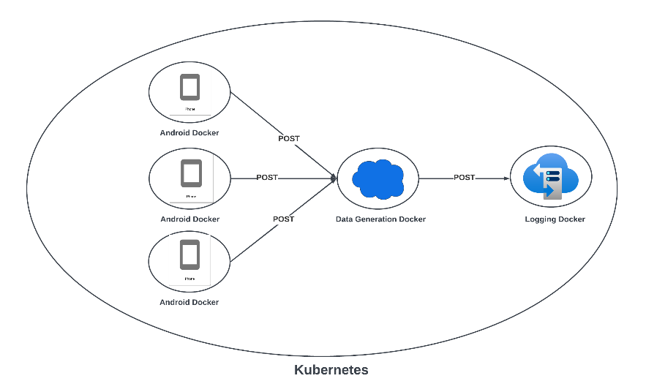
Fig. 1: Infrastructure Design for Data Collection [5]
The Android docker then forwards the data to the data generator docker, validating the data format and inserts entries when missing. This is necessary as some older model’s location and IP could not be set. Additionally, it generates additional entries based on each request when specified inside the Python script running the Flask application. Once finished, the logging server collects the generated data in a structured CSV format for analysis. Each user entry is tagged with a Universal Unique Identifier (UUID) to maintain traceability.
All services are run within an isolated Docker container, that is Kubernetes compatible, for rapid deployment. This was done through a yaml file that includes the different docker containers, including the Kubernetes networking that allows for each of the containers to communicate with each other. Since each docker is deployed via yaml file, the number of Android phones is easily changed. The infrastructure allows for full control over the environment variables, making it possible to simulate multiple concurrent users. Additionally, a containerized environment ensured consistent testing conditions, letting the entire system to be reproducible across different testing environments.
V. Analysis
To evaluate user authentication, two main approaches were used, Web Ontology Language (OWL) based reasoning and an SVM model. Since OWL represents a structured knowledge and applies logical rules to be able to infer new information. It enables complex relationships and hierarchies to be understood and analyzed, being useful in modeling user behavior and context in authentication systems. The analysis started with transforming the data from a CSV structure into an OWL ontology. Focusing on each user having a profile, and each profile having different phones with different entries. A Python script then converts CSV entries into RDF triples, a simple format used by OWL based reasoning. Using Protege, these ontologies were easily visualized.
Semantic Web Rule Language (SWRL) rules were applied to detect different deviations from expected behavior. For instance, if a user is found with a different IP, outside of their typical geolocation, or if their location is inconsistent, they would be labelled as an attacker. These rules helped to enable basic anomaly detection along with analyzing how it would respond to different attacks.
The second method used was SVM classification. This was trained on both real and augmented data. To improve the diversity of the dataset, this data was analyzed by a Generative Adversarial Network (GAN) to synthesize realistic user activity logs. GANs use generators and discriminators to generate new synthetic data. The generator creates fake data and feeds that into the discriminator which then detects if it’s real or fake. Through this competition, it can generate realistic results. An additional script was then used to generate spoofed attacker data based on user to attacker predefined ratio. The SVM model was then trained and tested to classify sessions as legitimate or adversarial. This allowed for more precision in detecting subtle patterns found in user behavior.
VI. Results
A total of 12,000 login attempts were used, split between users and adversaries employing basic techniques such as IP duplication, location spoofing, and timing mismatches. The SVM trained with a combination of real and GAN augmented data, able to achieve 98% accuracy with an error of 3% when using a larger number of data sets. [5] When ran against the different learning methods, such as KNN and RNN models, the SVM significantly outperformed, as such the SVM became the clear model to be used with this type of data.
Though the OWL reasoning did not produce numerical results, it was found to be effective for flagging obvious anomalies based on predefined rules and user context. The usability through SWRL rules would be a strong advocate for real world use. This is currently being expanded upon, to compare accuracy against a traditional model such as the SVM shown in figure 2 and 3.
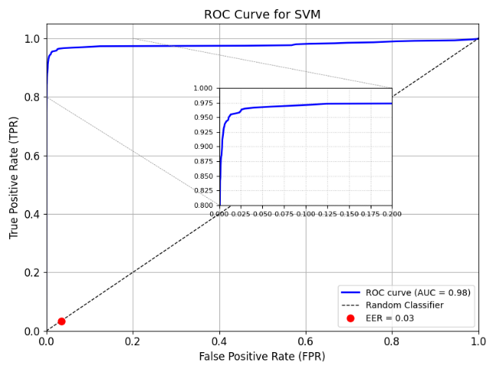
Fig. 2: ROC Curve – Expanded User and Attacker Set [5]
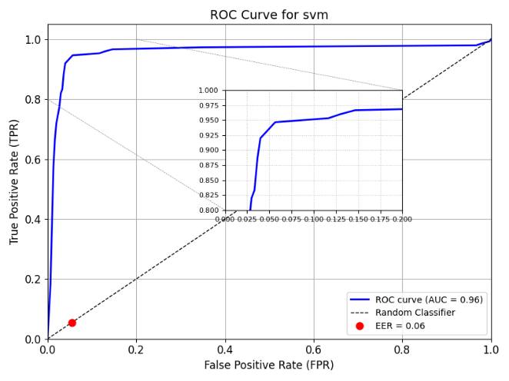
Fig. 3: ROC Curve – Limited User and Attacker Set [5]
The dataset used in the results from figure 3 uses a 5:1 user to attacker ratio. As shown, a limited set of data points were used which achieved 96% accuracy. When more data sets were applied, the accuracy improved to 98% with a lower Equal Error Rate (ERR). This error rate is the rate at which false acceptance equals the rate of false rejections. Meaning a lower ERR is establishing the system balances security and usability, making it a key metric when it comes to authentication accuracy. An ROC graph with a curve closer to the top left corner indicates better performance, with a steeper curve reflecting it has a higher true positive rate with fewer false positives. Since figure 2 has a steeper ROC curve, the model is found to be better at separating real users from attackers. [5]
VII. Conclusion
This research helped to demonstrate that combining contextual mobile data with machine learning models, like SVM and OWL, reasoning can significantly improve the accuracy and reliability of passive and continuous authentication. The experimental setup using simulated mobile environments, different adversarial scenarios, and data augmentation through GANs resulted in classification accuracies up to 98% and a 3% error rate. The SVM was found to significantly outperform the KNN and RNN models in both precision and efficiency, validating the usability for contextual security applications.
These results suggest that passive authentication frameworks will be able to replace or supplement traditional MFA approaches without decreasing security. When implemented correctly, this not only increases security but reduces the friction that users often express, leading to stronger overall secure practices. These findings confirm that behavioral and contextual signals, when processed by models like SVM, can match or exceed traditional MFA accuracy while enabling continuous authentication.
Future work should include evaluating these systems under more varied real-world conditions, including real user data rather than synthetic generation used here. Issues arrived as the GAN would be able to generate data which would overfit the SVM model, producing unrealistic results. Additionally, using new attack vectors, such as behavioral spoofing, would offer more insight into real-world attacks. Integrating more efficient classifiers and new learning techniques could also help address the different deployment challenges in resource-constrained environments that we so often see.
References
[1] Z. Shen, S. Li, X. Zhao, and J. Zou, “MMAuth: A Continuous Authentication Framework on Smartphones Using Multiple Modalities,” IEEE TRANSACTIONS ON INFORMATION FORENSICS AND SECURITY, vol. 17, pp. 1450, 2022. DOI: https://doi.org/10.1109/TIFS.2022.3160361
[2] H. Ma, Z. Li, and S. Mou, “Smartphone Continuous Authentication via Deep Behavioral Features and Isolation Forest,” in The 3rd International Conference on Signal Processing, Computer Networks and Communications (SPCNC 2024), Sanya, China, 2024.
[3] E. Hayashi, J. Hong, S. Das, I. Oakley, S. Amini, E. Owusu, J. Han, A. Perrig, and J. Zhang, “CASA: A Framework for Context-Aware Scalable Authentication.”
[4] S. Mare, R. Rawassizadeh, R. Peterson, and D. Kotz, “Continuous Smartphone Authentication using Wristbands,” in Workshop on Usable Security (USEC) 2019, San Diego, CA, USA, pp. 24, Feb. 2019. ISBN: 1-891562-57-6. DOI: https://dx.doi.org/10.14722/usec.2019.23013
[5] J. Sharp, A. Roy, A. Williams, D. Dasgupta, B. Womack, and C. Farkas, “Context-Aware and Adaptive Multi-Factor Authentication Model.”
[6] B. Alotaibi and M. Alotaibi, “Hybrid Deep Learning Framework for Continuous User Authentication Based on Smartphone Sensors,” Sensors, vol. 25, pp. 2817, 2025. DOI: https://doi.org/10.3390/s25092817
[7] “Password Leak Study Unveils 2025 Trends: Reused and Lazy Passwords,” CyberNews, 2025. [Online]. Available: https://cybernews.com/security/password-leak-study-unveils-2025-trends-reused-and-lazy/
[8] “Verizon 2024 Data Breach Investigations Report,” HIPAA Journal, 2024. [Online]. Available: https://www.hipaajournal.com/verizon-2024-data-breach-investigations-report/

